# Lesson 7 – Ciphers, LCD screen and GPS

Setting the scene

In this project you are going to learn about the importance of ciphers and how they can be used to protect data during transmission. You will learn how to connect an LCD screen to the Arduino in addition to being able to read a range of different GPS data from the MKR GPS shield.

# Success criteria

* Connect an LCD screen and to output text
* To be able to use a GPS sensor to record a location

# Step 1 – Building the circuit

You are going to connect the whole device and then test the LCD screen and GPS sensor separately.

# Pro-tip

The Arduino has a number of metal connectors exposed on the underside. As part of this project, you will be using your device outside to find a location in a treasure hunt. To help protect the exposed connectors from becoming bent, it is recommended that the Arduino is connected to a connector carrier or a breadboard.

You should then connect the circuit by following the circuit diagram below.

# Pro-tip

In order to make the circuit as neat as possible we recommend using shorter length cables.

Finally, connect the MKR GPS Shield using the provided cable or, if it has headers soldered on, by plugging it directly into the top of the Arduino. This is often a better and more robust option.

# Testing the LCD screen

To test the LCD screen is working correctly, upload the sample file, LCD_HelloWorld to your Arduino. If it is functioning correctly, you should see a welcome message printed on the screen. If it is not functioning correctly, check that your cables are connected correctly by following the instructions at the top of the sample file.

# Testing the GPS receiver

It is now time to test that your GPS receiver is functioning correctly. You should upload the sample file GPSLocation _no_LCD. If it is working correctly you should see a range of coordinates printed out onto the serial monitor in your IDE.

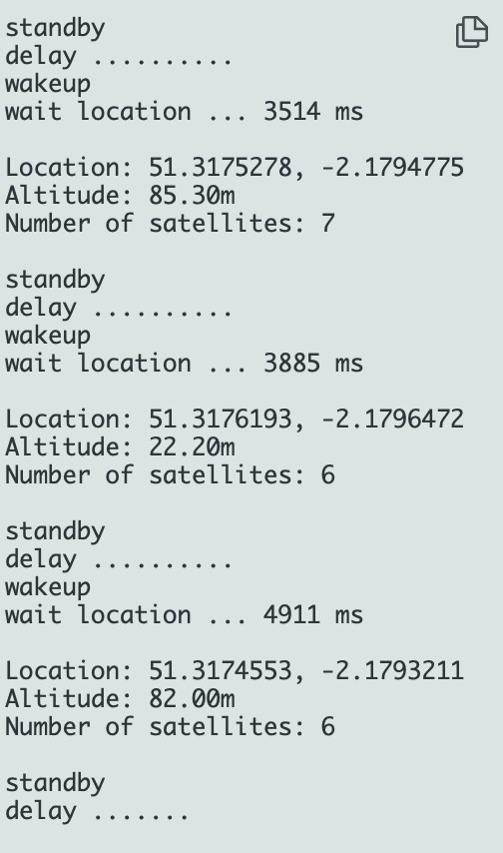

# Pro-tip

If you do not receive GPS data, you should test your device outside as buildings will often stop the GPS signal from being received via the sensor. Please note that it may take up to 5 minutes for your device to start to receive GPS readings. You can wander around with a laptop (get someone to give you a hand) or, once you have the screen connected, use a battery pack.

# Displaying GPS readings on the LCD screen

You are now going to add to your code to display the GPS coordinates onto the LCD screen. Please note that it will be necessary to remove ‘while (!Serial)’ loop in your in order to be able to use your device whilst not connected to the computer. The reason for this is that the loop will never exit as a connection with the USB will not be able to be established. The complete code is provided below.

The Serial.print lines have been left in to enable you to check your code with the monitor in the editor. Additional information such as number of satellites and altitude are also output into the monitor. If you wish to, you could add these to your lcd output. The two setCursor lines determine which row the data is output into on the LCD screen.

# Treasure hunt

You should now write one of your friends a secret message using a cipher of your choice and then choose somewhere to hide it. Once you have hidden it, you should make a note of the GPS coordinates. Your friend can then use the device to find the location to uncover your secret message. They should then try and crack the code.

To use your device outside it will need to be powered. The easiest way to do this is to use a battery pack from a mobile phone and plug the USB straight into that instead of your computer.

# Stretch tasks

Try to write a program using Python to encrypt and decrypt the message. Adjust your LCD output to include additional location information. Make the information scroll across the screen.

# Final thoughts

In this project you have learned to combine both input and output devices. You have also learned how to use location services with your device which lies at the heart of any GPS navigation system. All data that is transmitted wirelessly should be encrypted to ensure that if someone intercepts it, they will not be able to understand it.